* **Welcome page**: Admin Learner’s Academy portal

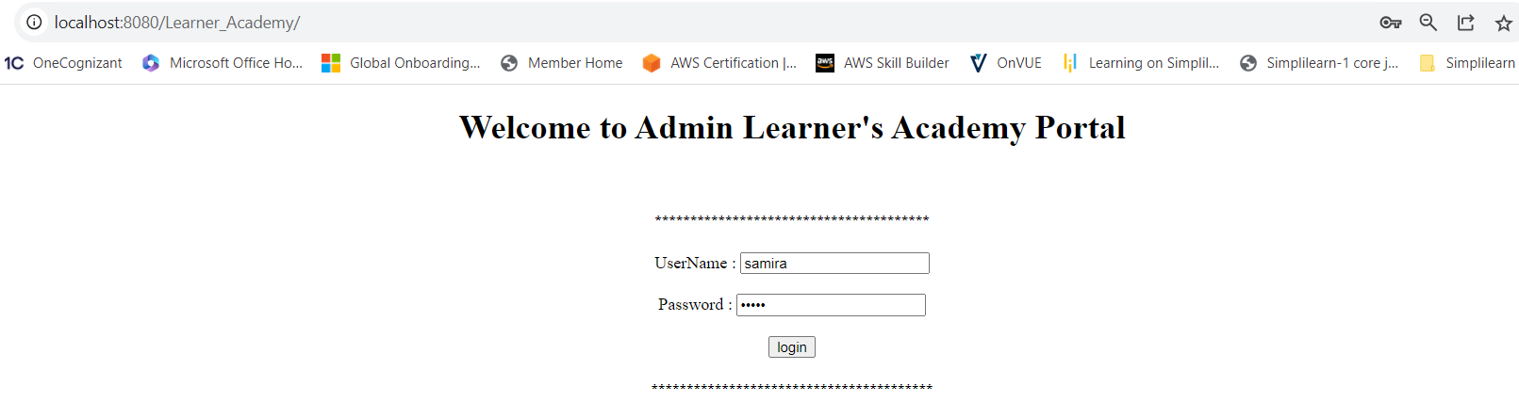

* Wrong admin username and password. It shows invalid credentials.

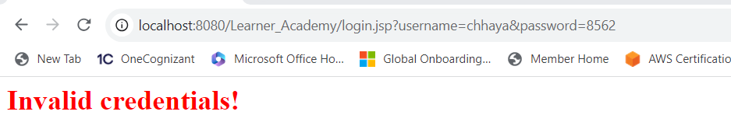

* With Correct username and password, it all you enter into the admin page.

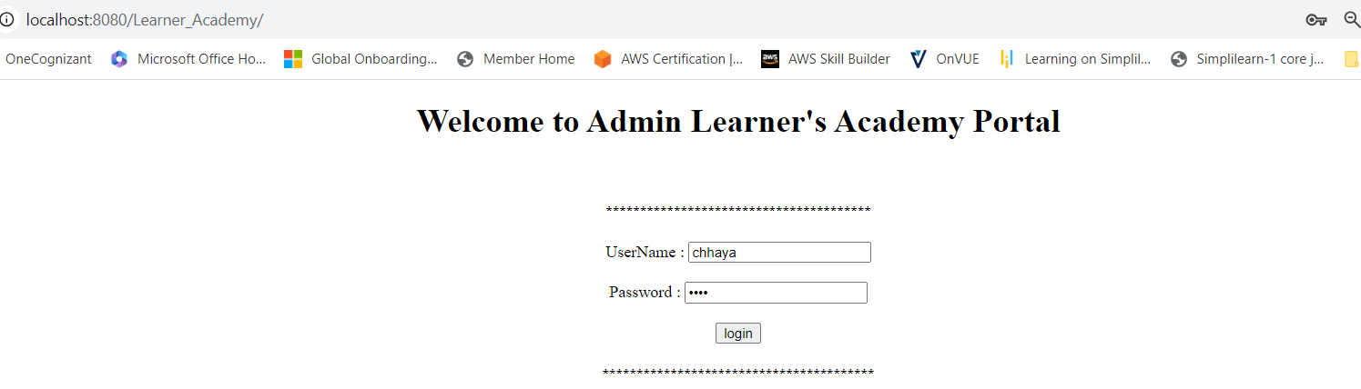

* Admin Home page having list of option: 1) Classes 2) Subjects 3) Teachers 4) Students

5) Logout

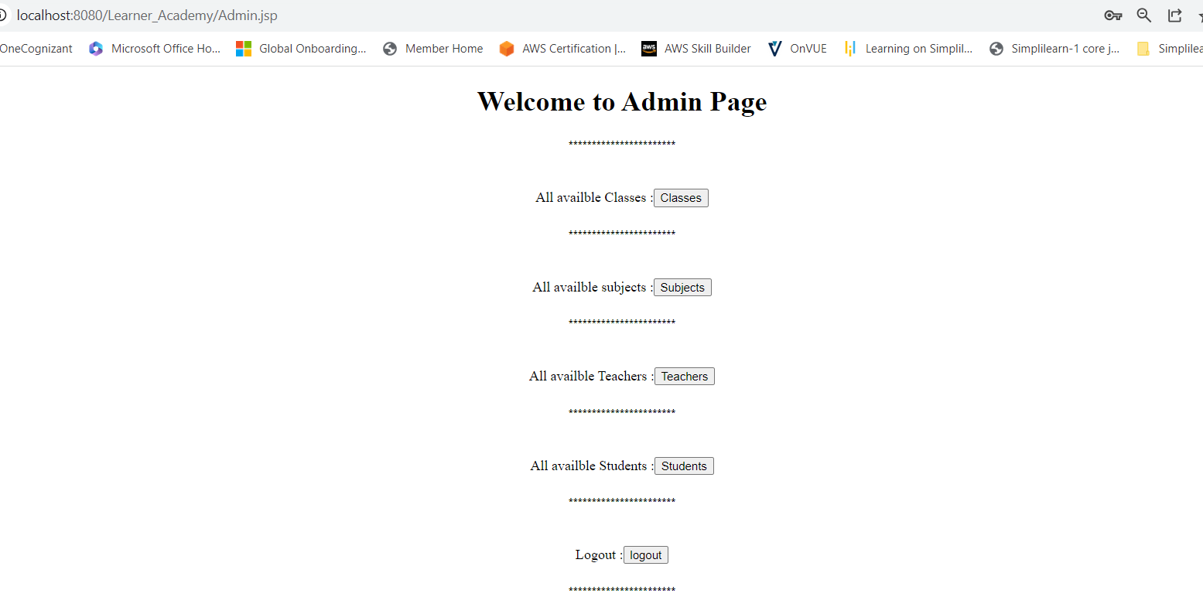

* 1)**Classes**: after clicked on classes button its show below page where admin have right selected subject and teacher for class.

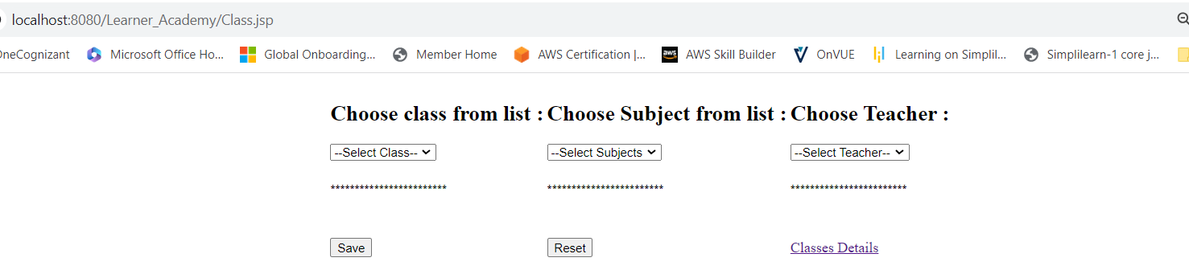

* One link showing for classes details from there you got all details abouts your classes, subject and teachers.

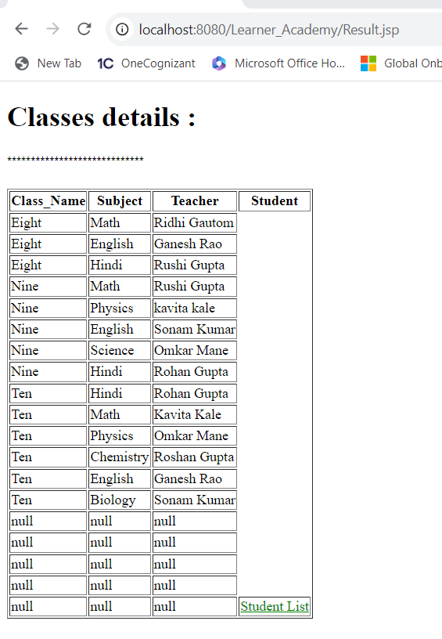

* Let’s select class, subject and teacher and show data

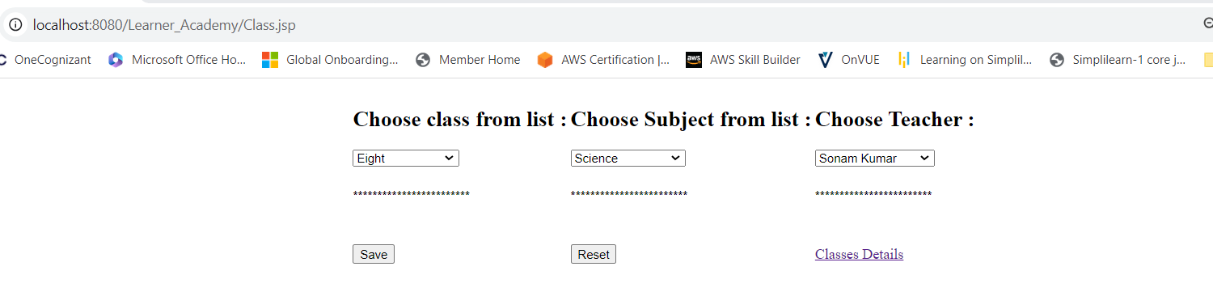

* After clicked on save and it will be showing classes details will latest record. As well student list option also available.

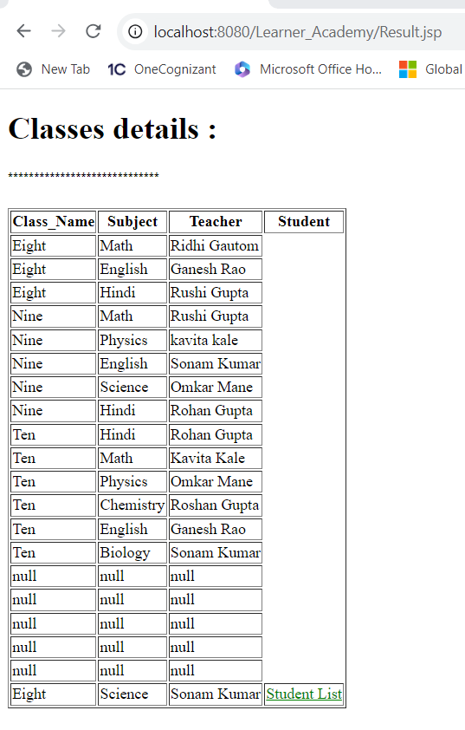

* Student details shows your list of students.

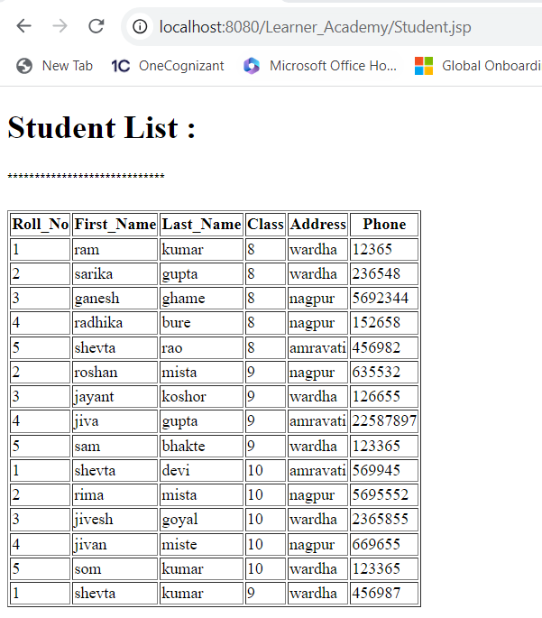

* Let’s go back admin home page:



* 2)**Subjects**: This option shows you all available subjects with there code.

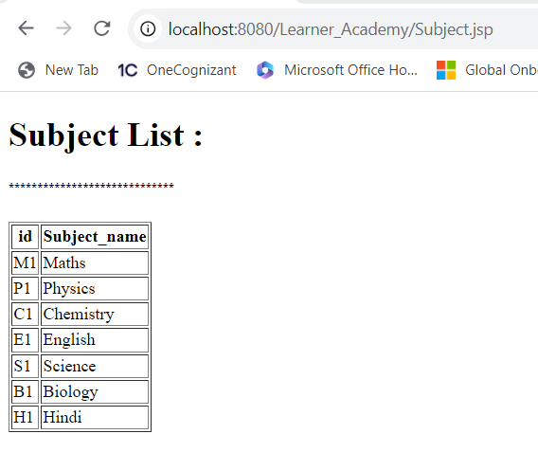

* 3)**Teachers**: This options showing you all available teachers with their basic details like first name ,last name , address ,age and phone

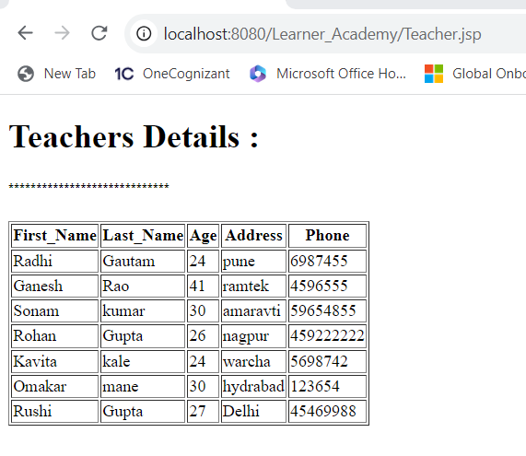

* 4) **Students**: This option shows you all student details with roll number, first name, last name, class, address, phone.

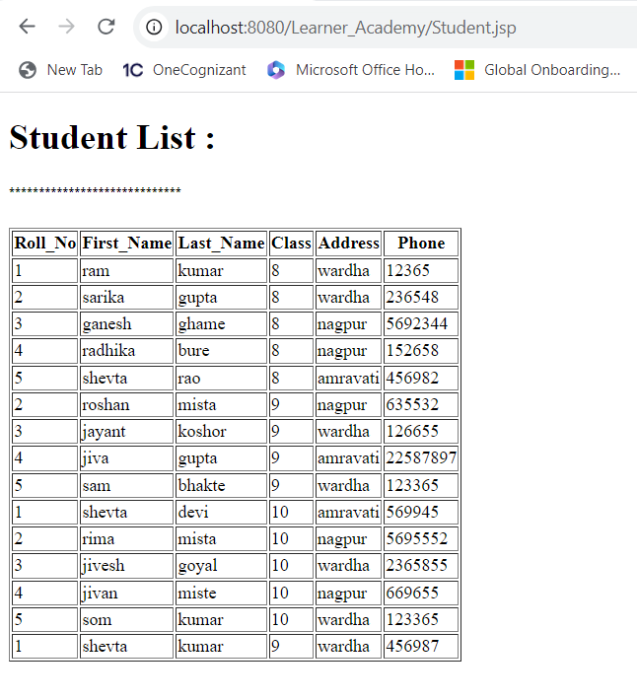

* 5) **Logoff**: This option allows admin logoff from portals, after click on logoff button it will show below page.

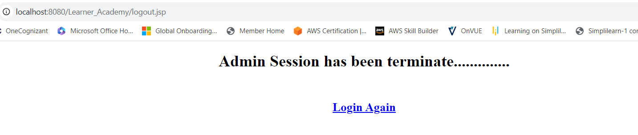

* As well it will show link for login again once your click login again it will redirect to welcome page.

